**//Sum of two matrices using two dimensional array**

#include <stdio.h>

#include <stdlib.h>

#include <conio.h>

int main(){

int matrix1[10][10], matrix2[10][10], sum[10][10], i, j, m,n,p,q;

printf("Enter the order of first matrix: ");

scanf("%d%d",&m,&n);

printf("Enter the order of second matrix: ");

scanf("%d%d",&p,&q);

if(m!=p && n!=q){

printf("Order of matrix did not matched!!");

exit(0);

}

printf("Enter first matrix: \n");

for(i = 0 ; i < m; i++){

for(j = 0; j < n; j++)

scanf("%d", &matrix1[i][j]); }

printf("Enter second matrix: \n");

for(i = 0 ; i < p; i++)

{

for(j = 0; j < q; j++)

scanf("%d", &matrix2[i][j]);

}

for(i = 0 ; i < m; i++){

for(j = 0; j < n; j++)

sum[i][j] = matrix1[i][j] + matrix2[i][j];

} printf("The sum of the matrix is :\n");

for(i = 0 ; i < m; i++){

for(j = 0; j < n; j++){

printf("%d", sum[i][j]);

printf("\t");

}

printf("\n");

}

getch();}

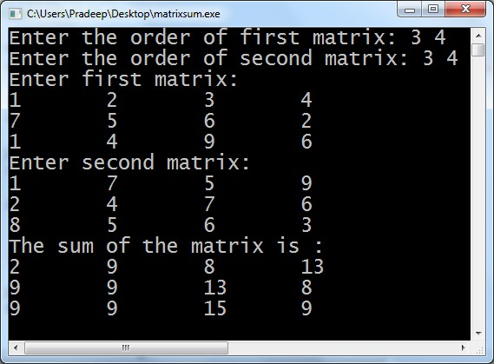

**//Sum of two matrices using two dimensional array**

#include<stdio.h>

#include<stdlib.h>

#include<conio.h>

int main(){

int matrix1[2][2], matrix2[2][2], sum[2][2], i, j;

printf("Enter first matrix: \n");

for(i = 0 ; i <2; i++){

for(j = 0; j < 2; j++)

scanf("%d", &matrix1[i][j]); }

printf("Enter second matrix: \n");

for(i = 0 ; i < 2; i++)

{

for(j = 0; j < 2; j++)

scanf("%d", &matrix2[i][j]);

}

for(i = 0 ; i < 2; i++){

for(j = 0; j < 2; j++)

sum[i][j] = matrix1[i][j] + matrix2[i][j];

} printf("The sum of the matrix is :\n");

for(i = 0 ; i < 2; i++){

for(j = 0; j < 2; j++){

printf("%d", sum[i][j]);

printf("\t");

}

printf("\n");

}

getch();}

